# 

# Submitted By:

# 

|  |  |  |
| --- | --- | --- |
| **Name** | **ID** | **Contribution** |
| NUSHRAT JAHAN | **22-46149-1** |  |
| TRIDIB SARKAR | **22-46444-1** |  |
| S.M. MUJAHID SOUROV | **22-49679-3** |  |
| MD. ATIK ISHRAK SUJON | **22-46684-1** |  |
| MD. FAHIM MURSHED | **22-46695-1** |  |

Date of Submission: , 2023

# TABLE OF CONTENTS

|  |  |
| --- | --- |
| **TOPICS** | **Page no.** |
| 1. **Cover Page** |  |
| **II. Table of Contents** |  |
| **Title** |  |
| **Abstract** |  |
| **Theory & Methodology** |  |
| **Apparatus** |  |
| **Experimental Procedure** |  |
| **Circuit Diagram** |  |
| **Images** |  |
| **IC Configuration** |  |
| **Simulation** |  |
| **Result & Discussion** |  |
| **References** |  |
|  |  |

* 1. **Title:**

Design of adder, subtractor and comparator circuits.

* 1. **Abstract:**

The purpose of this experiment is to learn the design and behavior of adder, subtractor and comparator logic circuits. Adders and subtractors are the most basic and most important part of digital electronics.

* 1. **Part I (Adder and Subtractor):**

Adders and subtractors are digital circuits which are capable of adding and subtracting binary digits. They are the most important part in the design of Arithmetic Logic Unit (ALU). In this experiment different types of adders and subtractors will be designed and their behavior will be observed.

* 1. **Theory and Methodology:**

**Adder:**

Adder is a digital logic circuit in electronics that is extensively used for the addition of numbers. Its two types: Half adder and Full adder. Half Adder, it adds two binary digits where the input bits are termed as augend and addend and the result will be two outputs one is the sum and the other is carry. A full adder has three inputs (A, B, and C-IN) and two outputs (Sum and Carry), while a half adder has two inputs (A and B) and two outputs (Sum and Carry); multiple full adders can be cascaded together to create a byte-wide adder with carry propagation.

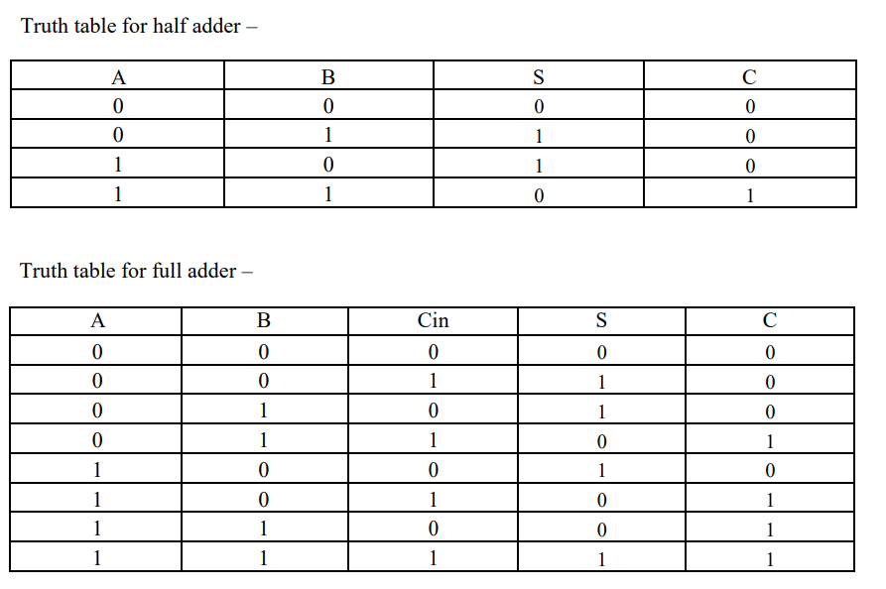

**Subtractor:**

The binary digits subtraction can be done with the help of the subtractor circuit. It has two types as Adder: Half Subtractor, Full Subtractor. The half subtractor circuit, utilizing NAND and EX-OR gates, performs subtraction on binary numbers and produces outputs for the difference and borrow. A full subtractor is a combinational logic circuit that performs subtraction on three binary inputs and produces outputs for the difference and borrow same as Full Adder Function.

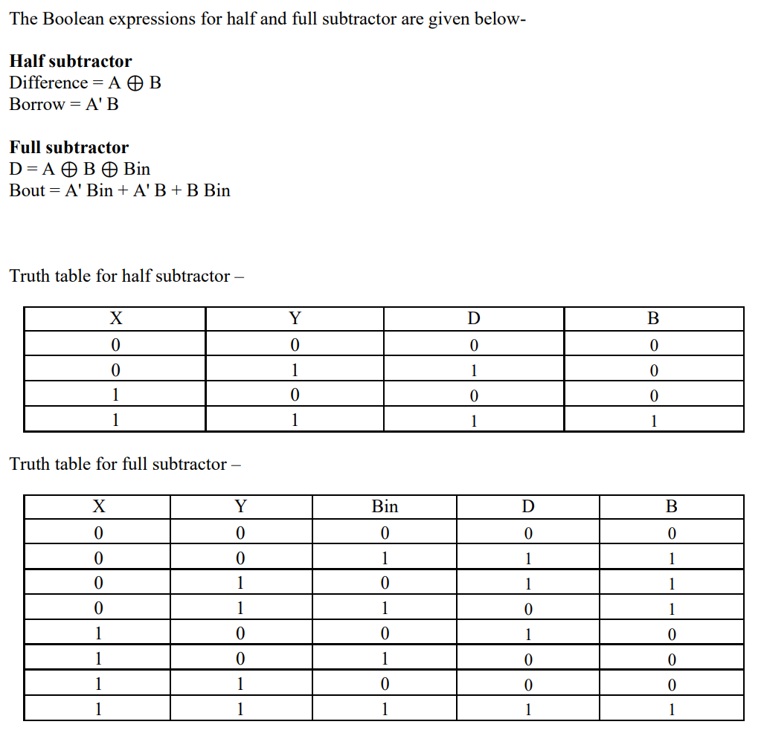

**Using Full Adder blocks for addition of n- bit systems:**

n number of 1-bit full adders need to be connected or “cascaded” together to produce what is known as a Ripple Carry Adder. A “ripple carry adder” is simply “n“, 1-bit full adders cascaded together with each full adder representing a single weighted column in a long binary addition. It is called a ripple carry adder because the carry signals produce a “ripple” effect through the binary adder from right to left, (LSB to MSB). For example, suppose we want to “add” together two 4-bit numbers, the two outputs of the first full adder will provide the first-place digit sum (S) of the addition plus a carry-out bit that acts as the carry-in digit of the next binary adder. The second binary adder in the chain also produces a summed output (the 2nd bit) plus another carry-out bit and we can keep adding more full adders to the combination to add larger numbers, linking the carry bit output from the first full binary adder to the next full adder, and so forth.

Here, the LSB of both word A and B (A0 and B0) are connected in the first stage full adder block and Cin of this block (Cin0) is connected to ground (as there is no carry in available at the initial stage). The MSB of both word A and B (A1 and B1) are connected in the first stage full adder block and Cin of this block (Cin1) is connected to the previous stage Cout (Cout0). Summation output for the LSB is available from the first stage Sum (S0). The next stage block outputs Sum (S1) and carry out (Cout1) provide the MSBs for the next stage output (S1 and S2).

* 1. **Part II: Comparator:**

A magnitude comparator is a device that takes in two sets of inputs in its input and compares them to provide an output, if they are equal, greater than or less than the other. In this experiment a 1-bit comparator will be designed at first and using the 1-bit comparator block, a 2-bit comparator will be designed.

* 1. **Theory and Methodology:**

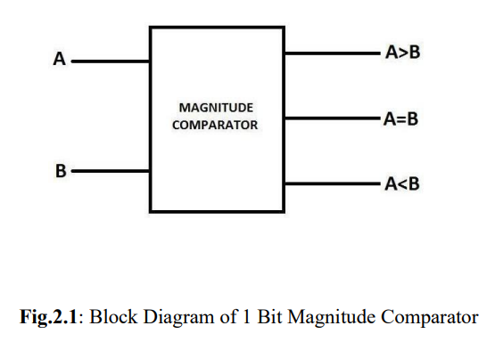A combinational circuit that compares two digital or binary numbers and compare them in the form of (A < B), (A = B) & (A > B) is known as magnitude comparator. A kind of magnitude comparator that compares two bits is known as 1 bit comparator. It consists of two inputs (A & B) each of 1 bit and has three outputs. The three outputs are A is less than B (A < B), A is equal to B (A = B) and A is greater than B (A > B). magnitude comparator that compares two bits, each of two bits is known as two-bit comparator. It consists of four inputs (A1, A0 & B1, B0) each of 1 bit and has three outputs. The three outputs are A is less than B (A < B), A is equal to B (A = B) and A is greater than B (A > B). [4]

Depending on the input combination for a 1-bit magnitude comparator, the following behavior table can be developed using the logic expressions.

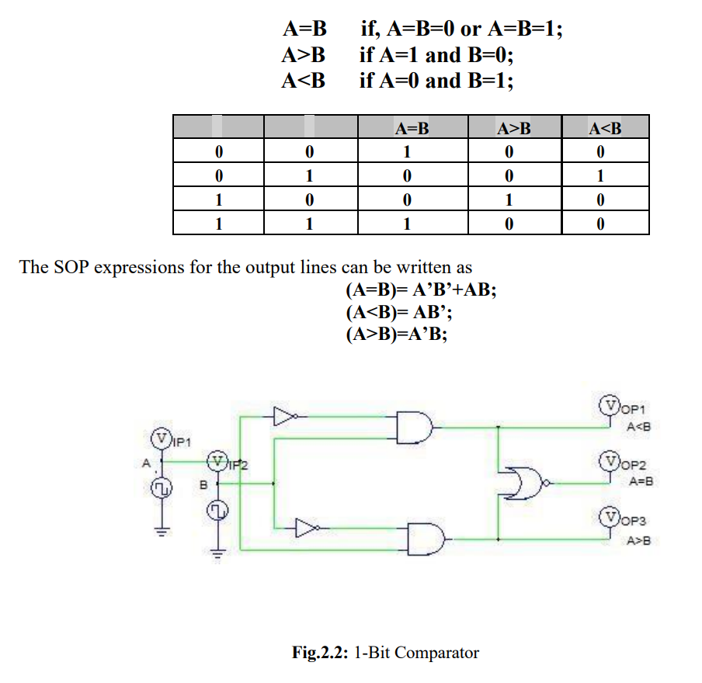

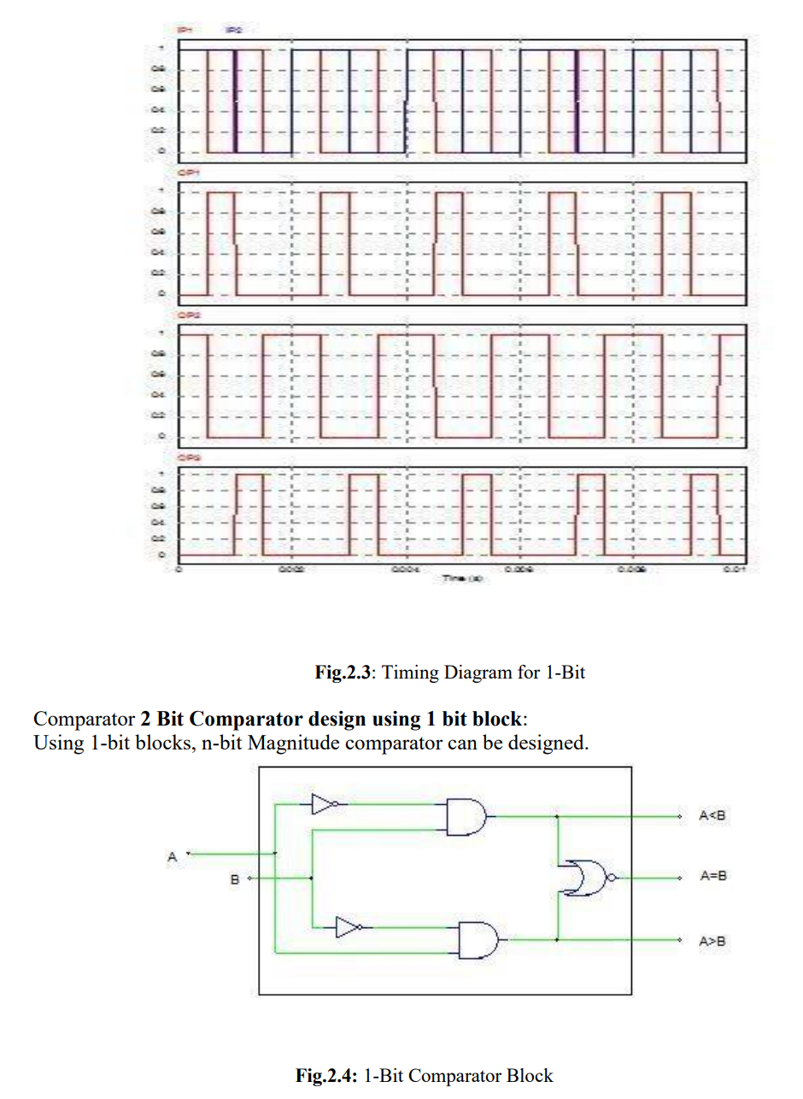

Designing a 2-bit comparator using 1-bit blocks:

Let us consider 2 words,

Word A_>A1A0, Word B_>B1B0

For comparing, the following process is used as writing the logic equations.

For A=B, If (A1=B1) & (A0=B0), then (A=B).

For A>B, If (A1>B1) then (A>B) or

if (A1=B1) & (A0>B0), then (A>B).

For A<B, If (A1<B1) then (A<B) or

if (A1=B1) & (A0<B0), then (A<B)

* 1. **Apparatus:**

1. Digital trainer board
2. IC 7408:2pcs
3. IC 7404:2pcs
4. IC 7486:2pcs
5. IC 7431:2pcs
6. IC 7483:1pcs
7. Connecting wires
   1. **Experimental Procedure:**
8. We determined the output and the truth tables of the logic circuits for full adder and half subtractor given in the theory and methodology part.
9. We determined which gates and how many of them are required, checked, and detected all the IC numbers.
10. We carefully placed the ICs on the Trainer Board and biased them by connecting them to the +5volt DC supply and ground.
11. We connected those using wires according to the logic diagram; also connected the outputs to the LEDs.
12. We checked and noted down the outputs by giving different inputs according to the derived truth table.
13. We designed a 2-bit full adder using IC 7483 and tried to verify its operation.

**1.9 Simulation and Measurement:**

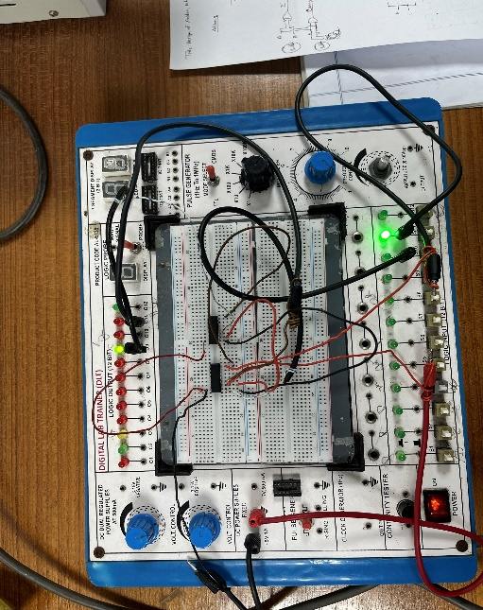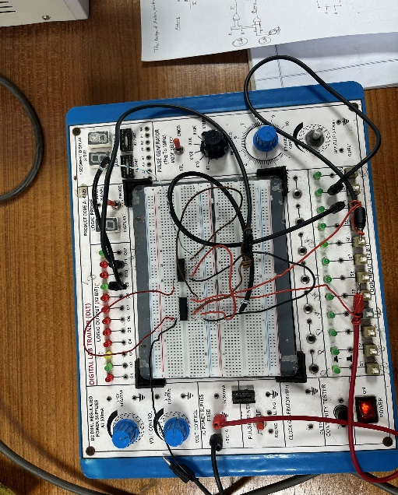**Experimental Circuit: Half Adder**

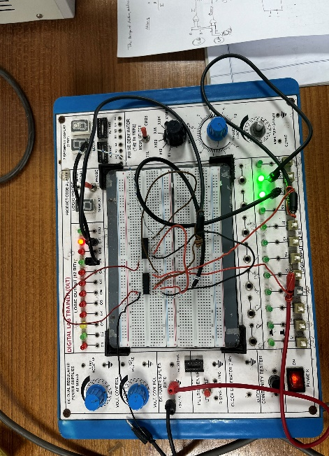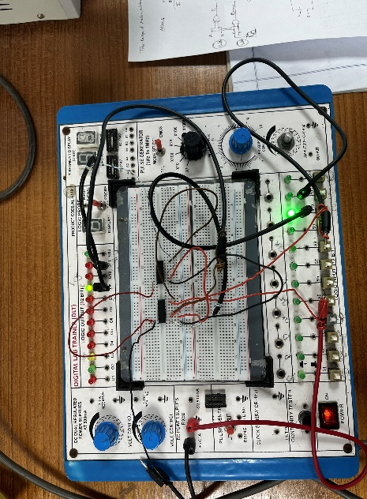

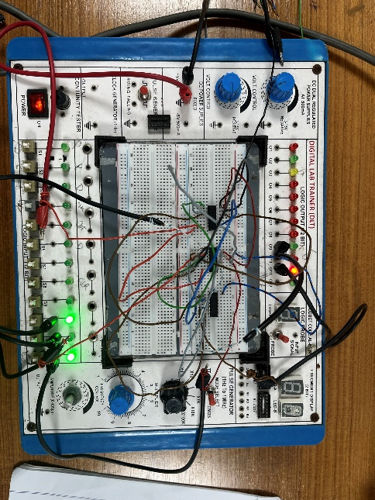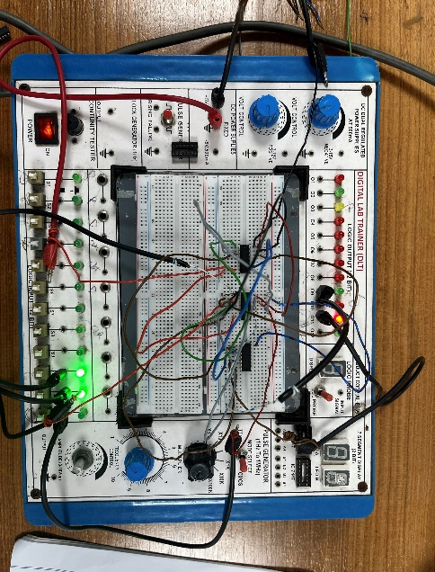 **Full Adder**

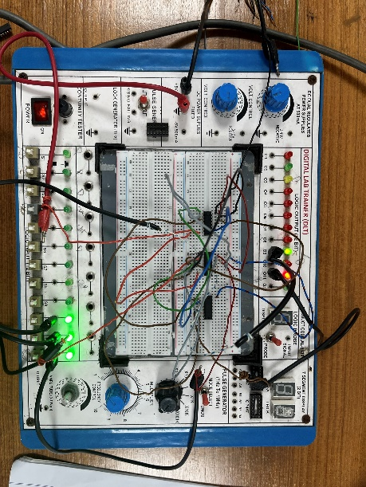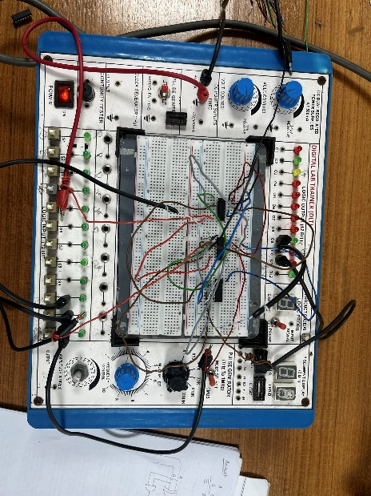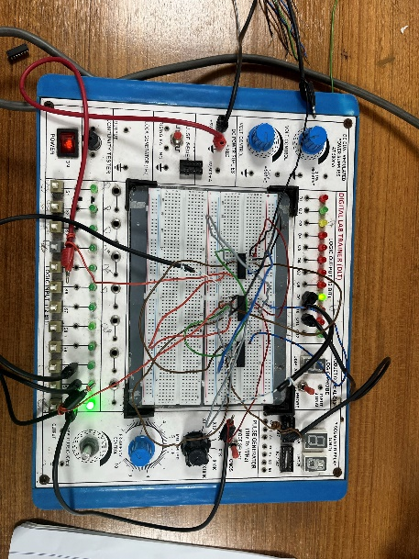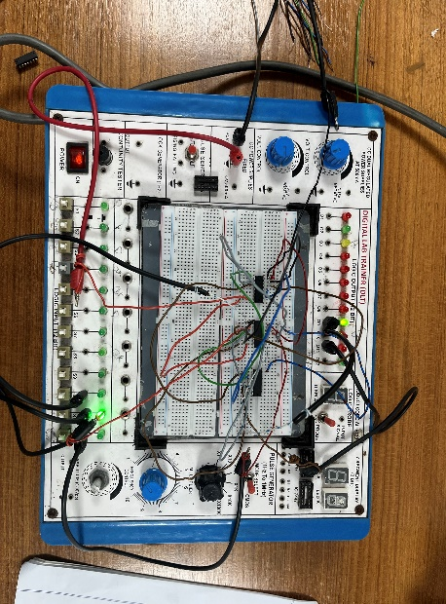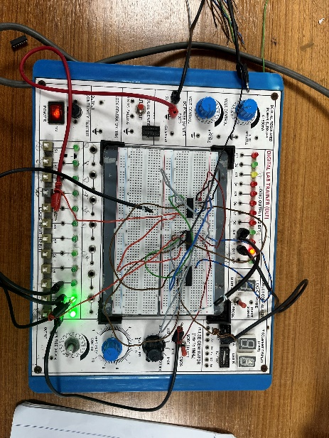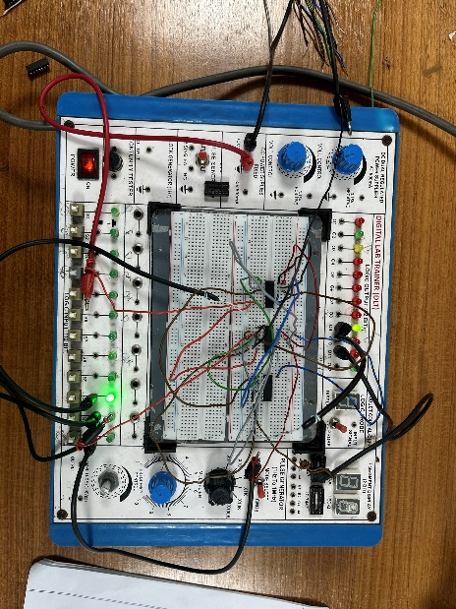

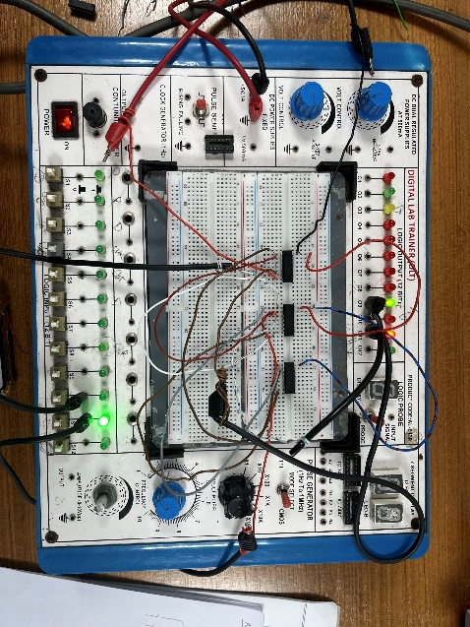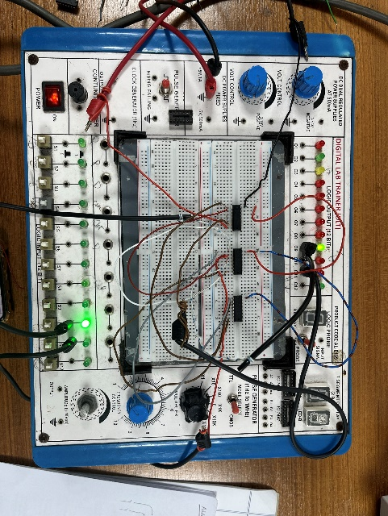

**Half Subtractor**

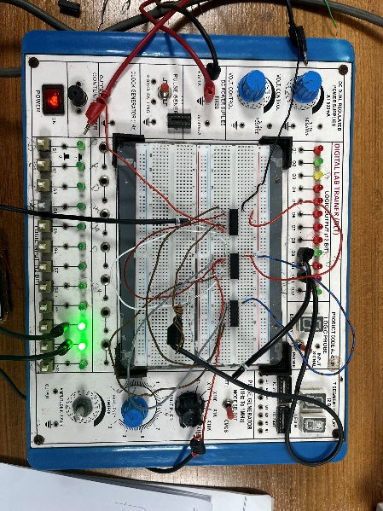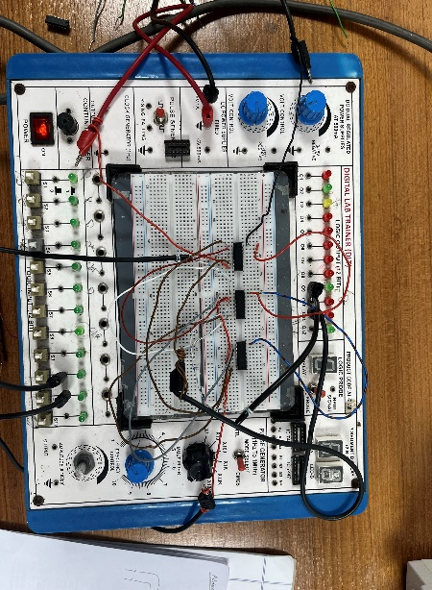

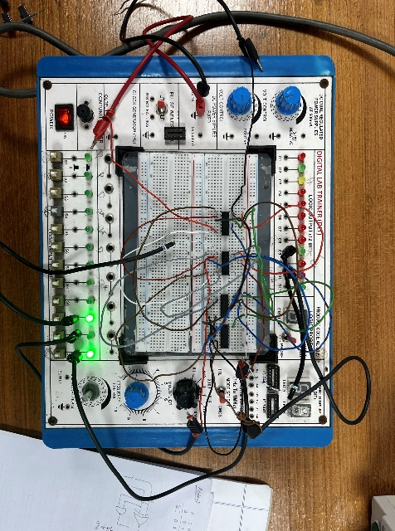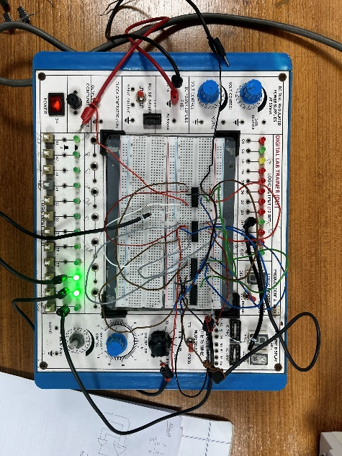

**Full Subtractor**

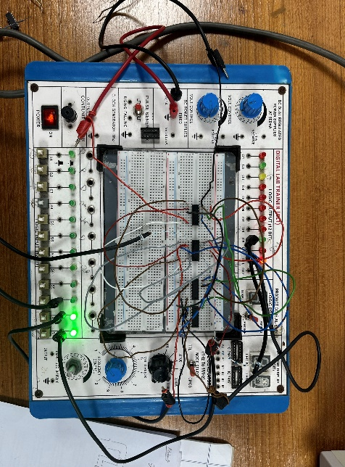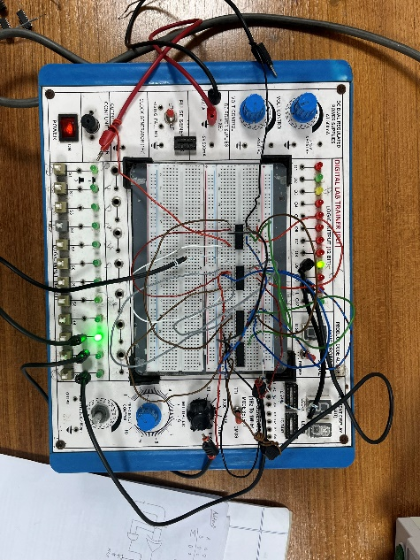

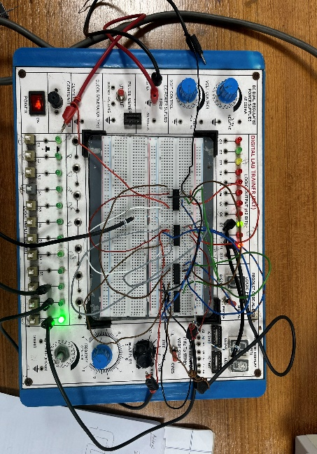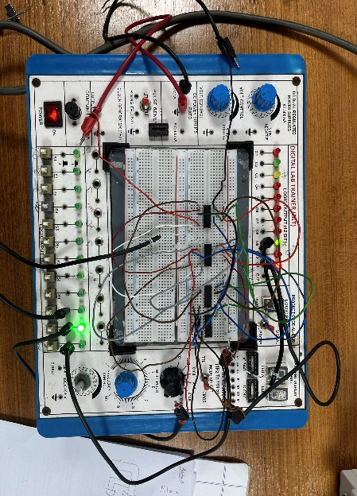

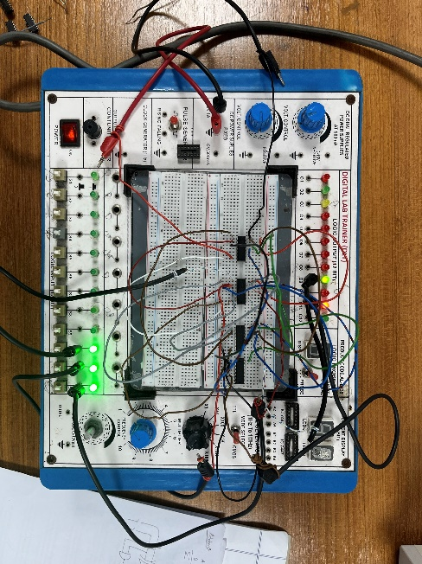 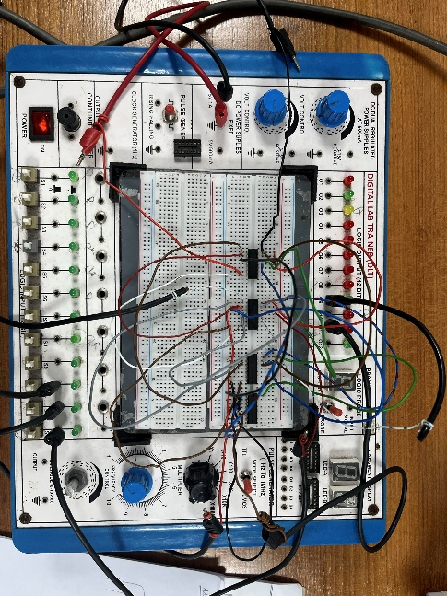

**One Bit Comparator**

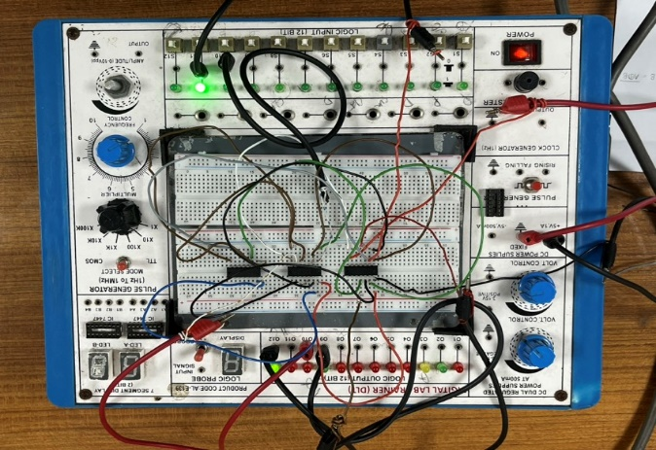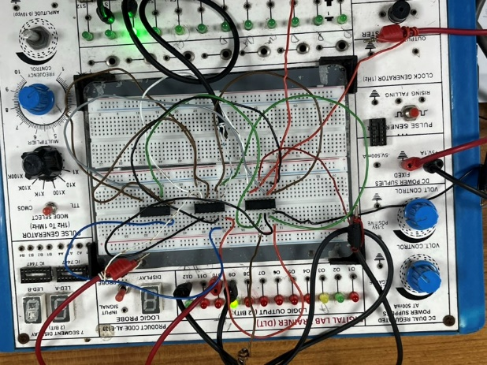

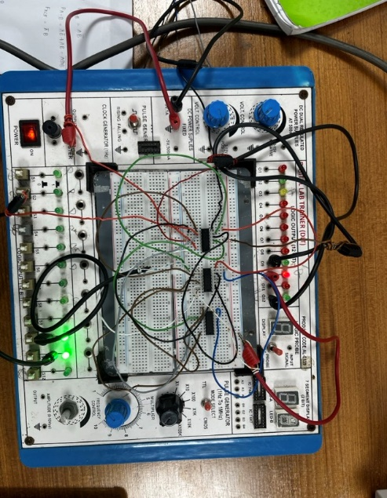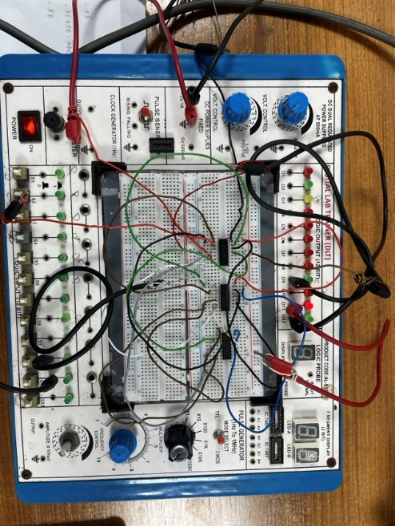

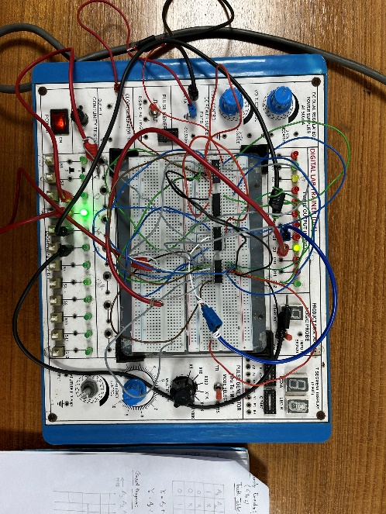

**Two Bit Comparator**

**1.8 Results & Discussion:**

In this lab experiment, we successfully designed and implemented combinational circuits for a half adder, full adder, subtractor, and 1-bit magnitude comparator. We verified their functionality by comparing the obtained truth tables with the expected theoretical results.

The outputs of the circuits matched the expected results for all input configurations, confirming their accuracy. We learned the importance of careful input configuration to ensure the circuits operated correctly.

This practical experience reinforced the theoretical concepts and highlighted the significance of half adders, full adders, subtractors, and magnitude comparators in digital logic design. Overall, the experiment deepened our understanding of combinational circuits and their applications in processors.

* 1. **Reference:**
* <http://www.circuitstoday.com/half-adder-and-full-adder>
* T. Agarwal, “Half Adder and Full Adder Circuit with Truth Tables,” ElProCus - Electronic Projects for Engineering Students, Jun 19. 2023. <https://www.elprocus.com/half-adder-and-full-adder/>
* T. Agarwal, “Half Subtractor and Full Subtractor Circuit Design - Theory, Truth Table, K-Map & Applications,” ElProCus - Electronic Projects for Engineering Students, Jun 19. 2023. <https://www.elprocus.com/full-subtractor-circuit-using-logic-gates/>